**User story:**

A user story is an informal explanation of one or more feature of the software system. End user perception is deliberated while writing user stories. Functionalities of the system being developed are influenced by these stories.

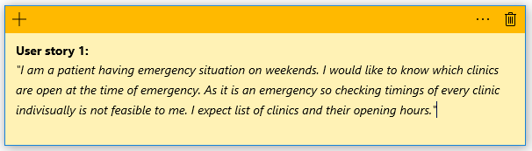

**Story decomposition:**

I *am a* user

*would like to* know list of clinics with their timings altogether

*So that* I would not face problem checking timings in emergency situation.

This user wants an application where he/she can easily get the list of clinics along with their timings such as open now or close now, in one go. As he/she will be facing an emergency situation so opening each clinic’s portal and checking opening and closing hours will not be time permissible.

**Story Elaboration:**

|  |  |  |
| --- | --- | --- |
| Start situation | Action | Outcome |
| Patient having emergency situation -  Do not have time to go on every clinic’s portal and then check whether the clinic is currently open or not depending upon patient’s disease and location. | * Select the doctor search option from application. * Enter search parameters. * Hit search button. | Patient will be satisfied as he/she will get output as a list of doctors along with timings of clinic in one go.  Emergency situation patient will be glad as time will be saved. |

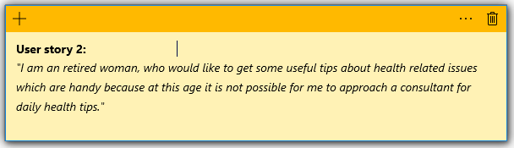

**Story decomposition:**

I *am a* retired woman

*would like to* get some useful health related tips

*So that* every time I need not go to a health consultant for minor problems.

This user would like some platform for beneficial and handy health related tips regarding as it is not possible for the user to every time consult an expert for home remedies or minor suggestions.

**Story Elaboration:**

|  |  |  |
| --- | --- | --- |
| Start situation | Action | Outcome |
| A retired woman -  Would like to get some useful health related tips and home remedies.  Do not want to visit a consultant for these tips. | * Select the health articles option from application. * Choose articles from the given list according to interest. * Read the articles. | Person will get desired knowledge handy and easily. |

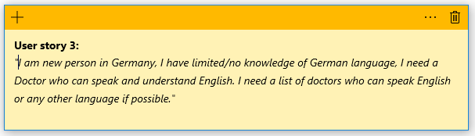

**Story decomposition:**

I *am a* new person in Germany

*Need a* doctor who understands and speaks English

*So that* I do not have to face communication problem with him/her.

This user faces communication problem due to lack of German language knowledge. So he/she expects a list of doctors who are comfortable with English so that it will be beneficial at the time of treatment or consultancy.

**Story Elaboration:**

|  |  |  |
| --- | --- | --- |
| Start situation | Action | Outcome |
| A user new to Germany -  Having limited or no knowledge of German language needs a doctor with whom he/she can communicate in English. | * Select the doctor search option from application. * Enter search parameters. * Select Clinic from list where doctor can speak English. | User will be happy as he/she do not need to face communication problem with doctor. |

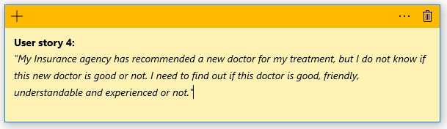

**Story decomposition:**

I *am a* user

*would like to* know about the doctor’s reviews

*So that* I can decide to visit this doctor or not.

This user wants to have some initial information about the doctor. Factors like doctor’s character, experience, ratings, etc. will be useful for this user to decide whether to visit the doctor or not.

**Story Elaboration:**

|  |  |  |
| --- | --- | --- |
| Start situation | Action | Outcome |
| A user -  Whose insurance company has recommended him/her a new doctor.  So user wants to know whether recommended doctor is trust worthy or not. | * Select the doctor search option from application. * Enter search parameters. * Look for star rating of doctor individually. | User will get to know whether the recommended doctor is friendly, good, experienced or not. |

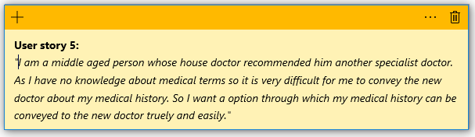

Story decomposition:

I *am a* middle aged user

*would like to* have an option to provide my medical history

*So that* I do not face problem conveying the new doctor about my past medical condition.

This user is not technically sound about the medical terms. He/she wants that his/her medical history to be conveyed to the doctor through some application which will avoid miscommunication.

**Story Elaboration:**

|  |  |  |
| --- | --- | --- |
| Start situation | Action | Outcome |
| A user -  Whose house doctor recommended him a new specialist.  He/she wants that his past medical records to be conveyed to new doctor accurately to avoid miscommunication. | * Login/register to the application. * Choose the option of uploading medical record in form of a document. * Show this uploaded document to new doctor when needed. | User do not need to verbally tell new doctor about his/her past records.  There will be no problem of false communication. |

**User story mapping:**

|  |  |  |  |
| --- | --- | --- | --- |
| **User Story** | **Search** | **Login/Register** | **Upload** |
| A patient having emergency situation would like to know which clinics are open at the time of emergency.  As it is an emergency so checking timings of every clinic indivisually is not feasible to me. | User can select the option of doctor search in the application.  The search will result into a list of doctors with their timings. | NA | NA |
| As a retired woman, I would like to get some useful tips about health related issues which are handy because in this age it is not possible for me to approach a consultant for daily health tips. | User can select the option of Health articles from the application.  He/she can filter which category of articles he/she would like to read. | NA | NA |
| I am new person in Germany, I have limited/no knowledge of German language, I need a Doctor who can speak and understand English. | User can select the option of doctor search through the application.  This search will enlist the doctors along with languages known. | NA | NA |
| My insurance company has recommended me a new doctor for my treatment, but I do not know if this new doctor is good or not. | User can select doctor search option from the application.  Then look for reviews and star ratings of every doctor individually. | NA | NA |